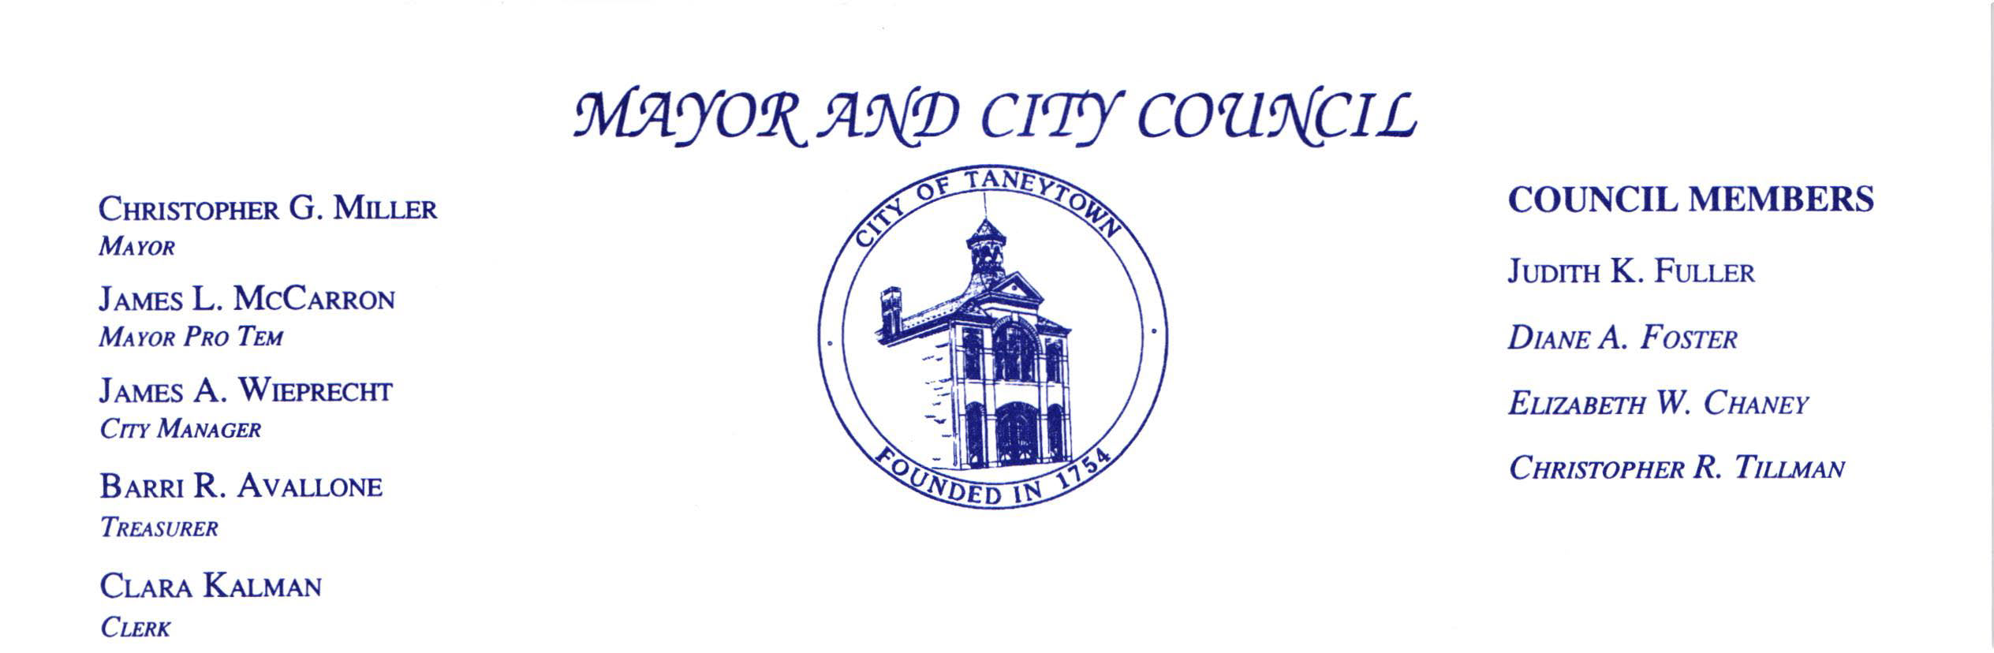

Notice of Closed Session
January 13, 2025
following the 7:30 PM
Mayor and Council Meeting

Closed Session: pursuant to § 3 – 305 (b) (7) of the General Provisions Article of the Maryland Annotated Code, to consult with counsel to obtain legal advice and § 3 – 305 (b) (1) (i) (ii) to discuss the appointment, employment, assignment, promotion, discipline, demotion, compensation, removal, resignation, or performance evaluation of an appointee, employee, or official over whom it has jurisdiction; or any other personnel matter that affects one or more specific individuals.

The Mayor and City Council will NOT reconvene in public session after the discussion.

